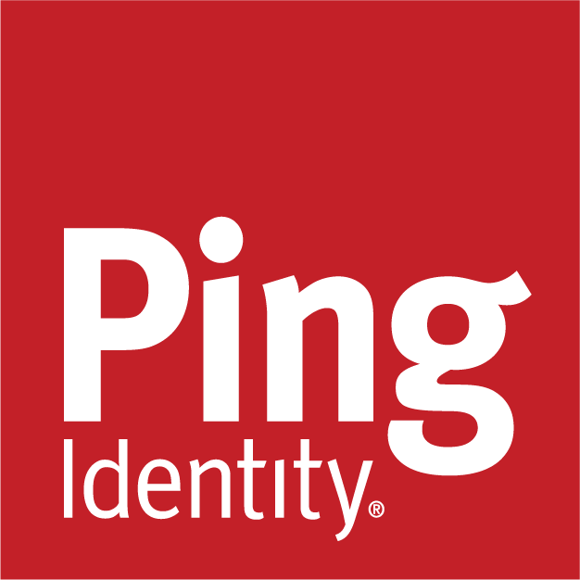

Partner Delivery Kits
Project Handover Template
Ping Professional Services
20th February 2026
v1.0

Table of Contents
Handover Documentation Template 3
1. Project Information: 3
2. Delivery Summary 3
2.1 Scope of delivery 3
2.2 Business objectives 4
3. Solution Overview 4
3.1 High‑level architecture 4
3.2 Ping Identity components 5
3.3 Key external dependencies 5
4. Application & Use Case Overview 5
4.1 SAML applications (PingFederate / PingOne) 5
4.2 OAuth / OIDC applications 6
4.3 Authentication policies (PingFederate) 6
4.4 Web/API applications (PingAccess) 6
4.5 MFA‑protected applications (PingID / PingOne MFA) 6
4.6 Directory use cases (PingDirectory) 7
5. Environment Overview 7
5.1 Environments 7
5.2 Infrastructure & hosting 7
5.3 Network & connectivity 8
5.4 Key URLs & endpoints 8
6. Data Sources & Identity Stores 8
7. Implementation Assets & Documentation 8
8. Custom Components / Kits (If Applicable) 9
9. Known Issues, Constraints & Production Notes 10
9.1 Issues / challenges during implementation 10
9.2 Production items of note 10
9.3 Logging, monitoring & observability 10
9.4 Upgrade & maintenance considerations 10
10. Key Contacts & Roles 11
10.1 Customer contacts 11
10.2 Delivery team / vendor contacts 11
11. Customer Terms & Acronyms 11
12. Open Actions & Recommendations 12
13. Appendices (Optional) 12

Handover Template
This template is intended for general handover of a solution from one team to another (e.g., PS → customer ops, PS → partner, project → BAU). It captures the key information required to understand, operate, and extend the delivered solution, based on the structure and content used in existing Ping PS handover documents.

Replace all bracketed guidance text ([example]) with project‑specific content.

1. Project Information:
- Customer / Organization: [Customer name]
- Project Name: [Project or solution name]
- Handover Audience: [e.g. Customer Ops, Internal Support, Partner, Next PS Team]
- Project Reference: [Internal project code / SOW / JIRA epic]
- Opportunity / CRM Reference: [Opportunity ID, if relevant]
- Contract / Order Number: [Contract number or link]
- Go‑Live Date(s):
  - [Environment / use case] – [Date/Time with timezone]
- Last Updated: [YYYY‑MM‑DD]
- Version: [v1.0, v1.1, etc.]

Prepared by

- Name: [Your name]
- Role: [e.g. Partner Delivery Architect, PS Consultant]
- Email: [email@pingidentity.com]

2. Delivery Summary

2.1 Scope of delivery
Professional Services / Project team delivered the following capabilities:

- [High‑level capability 1 – e.g. PingFederate cluster in AWS with HA, SSO to O365, etc.]
- [High‑level capability 2]
- [High‑level capability 3]

In Scope

- [Bulleted list of in‑scope items]

Out of Scope / Deferred

- [Bulleted list of out‑of‑scope or deferred items]

2.2 Business objectives
- [Short description of the business drivers for this solution (e.g., MFA rollout, Protect deployment, CIAM modernization)]

3. Solution Overview

3.1 High‑level architecture
- Short description: [1–3 sentences describing how the components fit together]
- Architecture diagram(s):
  - [Link to primary network / solution diagram]

3.2 Ping Identity components
Ping Product / Service | Version | Role in Solution | Notes
[PingFederate] | [e.g. 11.3.x] | [e.g. SSO, IdP/SP, OIDC provider] | [Any special notes]
[PingAccess] | [version] | [Web/API protection]
[PingOne Protect] | [tenant/env] | [Risk evaluation, policies, predictors]
[PingID / PingOne MFA] | [version] | [MFA provider, policies]
[PingDirectory] | [version] | [Directory / data store use]

3.3 Key external dependencies
- IdPs / SPs / RPs: [e.g. ADFS, Azure AD, O365, custom apps]
- Data sources: [AD, DBs, HR systems, etc.]
- Network / Security: [Load balancers, firewalls, WAF, VPNs, etc.]

4. Application & Use Case Overview
Use this section to document the major application integration types, based on the question sets in the original template.

4.1 SAML applications (PingFederate / PingOne)
- Number of SAML applications: [Approximate count]
- Major SAML applications:
  - [App 1 – description]
  - [App 2 – description]
- Customer acting as: [IdP / SP / both]
- Federation hub / IdP‑SP bridging?: [Yes/No – details if Yes]
- OGNL usage: [Yes/No – brief description if Yes]

4.2 OAuth / OIDC applications
- Number of OAuth/OIDC clients: [Count]
- Major OAuth/OIDC applications:
  - [Client 1 – flows, scopes]
  - [Client 2 – flows, scopes]
- Flows used: [Auth Code, PKCE, Hybrid, Client Credentials, etc.]
- Scopes usage: [How scopes are structured and used]

4.3 Authentication policies (PingFederate)
- Number of authentication policies: [Count]
- Selectors & adapters (with versions):
  - [Selector/Adapter name – version – purpose]
- Custom adapters/selectors?: [List any PS‑built/custom components]
- Usage: [IdP, SP, OAuth, OIDC, or mix]

4.4 Web/API applications (PingAccess)
- Number of protected apps/APIs: [Count]
- Protection model: [Gateway / Agent / Mix]
- Policy complexity: [Simple, moderate, advanced; note key Groovy/policy scripts if any]

4.5 MFA‑protected applications (PingID / PingOne MFA)
- Apps protected by MFA:
  - [App 1 – use case]
  - [App 2 – use case]
- PingID / PingOne MFA policies in use: [Summary]
- Enrollment strategy: [Just‑in‑time, bulk enrollment, self‑service, etc.]
- Authentication types enabled: [Mobile app, FIDO2, SMS/Voice, Email, etc.]
- Workstation / SSH / Windows Server use cases?: [Yes/No – details]
- PingID SDK vs server‑side PingID: [Which is used]

4.6 Directory use cases (PingDirectory)
- Applications using PingDirectory: [List]
- Deployment scope: [Regional / national / global]
- Additional components: [Directory Proxy, DataSync, DataMetrics, Delegated Admin]
- Administration model: [Who and how directory is managed]
- Custom sync pipes?: [Yes/No – description]

5. Environment Overview

5.1 Environments
- Environments:
  - [e.g. Customer Prod, Employee Prod, Pre‑Prod, Test, Dev]
- Purpose & differences: [Brief description per environment]

5.2 Infrastructure & hosting
- Hosting model: [On‑prem, private cloud, AWS, Azure, GCP, hybrid]
- Server info:
  - OS / platform: [RHEL / Windows Server / container platform, etc.]
  - Typical sizing: [RAM, CPU, Disk]
- Cluster / HA:
  - [Cluster topology and any active/passive or active/active details]

5.3 Network & connectivity
- Network diagrams:
  - [Link to primary network diagram]
- Key routing / VPC notes:
  - [e.g. Transit VPC, security VPC connections, network paths]
- Load balancers / proxies / WAF:
  - [Brief description and where they sit in the flow]

5.4 Key URLs & endpoints
- Admin consoles: [PF admin URL, PA admin URL, PingOne Admin, etc.]
- User‑facing URLs:
  - [Login portals, PingOne Dock/Launchpad, vanity URLs]

6. Data Sources & Identity Stores
- Directories:
  - [AD, PingDirectory, LDAP, etc., with versions]
- Databases / other stores:
  - [Name, purpose, critical schemas if relevant]
- Sync / provisioning flows:
  - [Summary of how identities are provisioned/synced]

7. Implementation Assets & Documentation
List all key artefacts produced during delivery, with working links.

- Detailed design:
  - [Document name] – [Link] – [Status: final/draft]
- Runbook / Operations guide:
  - [Document name] – [Link]
- Infrastructure as Code / Automation:
  - [Repo name – purpose – link]
- Test plans / acceptance criteria:
  - [Document or JIRA references]

8. Custom Components / Kits (If Applicable)
Document any custom adapters, integration kits, scripts, or tooling that are part of the solution.

Component / Kit Name | Version | Purpose / Description | Source / Repo (instructions & code) | Build / Binary Location | Test / Demo Environment
[Custom Adapter / Kit] | [vX] | [What it does] | [Git repo URL] | [Compiled JAR / package location] | [URL or description]
[Additional component]

Include any special build steps or dependencies here.

9. Known Issues, Constraints & Production Notes

9.1 Issues / challenges during implementation
- [Issue 1 – description, impact, mitigation/workaround]
- [Issue 2 – description, impact, mitigation/workaround]

9.2 Production items of note
Call out any special behaviours or configurations the next team must know (e.g., vanity URLs, session configuration, non‑standard flows).

- [Item 1 – description]
- [Item 2 – description]

9.3 Logging, monitoring & observability
- Logging: [Where logs go, log aggregation/SIEM, any gaps (e.g., SYSLOG not yet implemented)]
- Monitoring & alerting: [Tools and key alerts for this solution]

9.4 Upgrade & maintenance considerations
- Current versions & support windows: [Summary]
- Planned upgrades: [Any known roadmap or required upgrades]

10. Key Contacts & Roles

10.1 Customer contacts
Name | Role / Responsibilities | Ping Experience / Skills | Contact Info
[Name] | [e.g. Platform Engineer, IAM Lead] | [Knowledge of flows/admin level] | [email / phone]
[Name]

10.2 Delivery team / vendor contacts
Name | Role / Responsibilities | Contact Info
[Name] | [e.g. Project Manager] | [email / phone]
[Name] | [e.g. Lead Engineer / Architect] | [email / phone]

11. Customer Terms & Acronyms
Capture any customer‑specific terminology or acronyms that appear in the solution or documentation.

Term | Definition / Meaning
[Acronym] | [Customer‑specific meaning]
[Term] | [Definition]

12. Open Actions & Recommendations
- Open actions:

  - [Action 1 – owner – target date]
  - [Action 2 – owner – target date]

- Recommendations (future improvements):

  - [Recommendation 1 – e.g. enable staging policies, expand Protect coverage]
  - [Recommendation 2]

13. Appendices (Optional)
Use appendices for:

- Detailed application questionnaires (SAML/OIDC/PingAccess/PingID/PingDirectory) if you want to preserve the question lists for future expansion.
- Additional network diagrams or data models.
- Detailed configuration exports or reference screenshots (if not already in the runbook).

